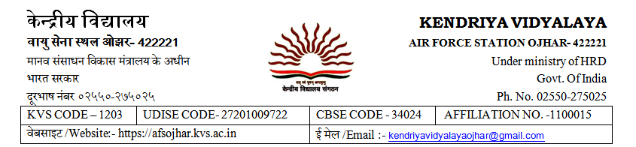

Date:17/02/2020

**NOTICE**

This is to inform that the **Firm Registration** date has been extended from 17th February 2020 to 20th February 2020 up to 12.00pm due to administrative reasons.

PRINCIPAL